1st Annual “Timber Rattlers Experience”
Information
- Buy Timber Rattlers ticket vouchers and receive a unique experience for your team!
- Vouchers are sold for $10 each (Usually they sell for $12)
- Vouchers are good for any home Timber Rattlers game
- I will work the tournament schedule around the game you pick if needed
- Buy as little or as many as you’d like (They all count for the tournament total)
- Vouchers can be mailed to you or picked up at Will Call
- Vouchers gets traded in for a ticket to the game at the gate or over the phone with the Timber Rattlers at 920-733-4152.
- Contact Cole with any questions or your order: UltimateSportsWeekend@yahoo.com
Experiences
- 20 Tickets
  - Have your team recognized on the jumbotron at a Timber Rattlers game
- 40 Tickets
  - Exclusive early entry so you can watch the Timber Rattlers take BP
  - Visiting team is directly after that
- 60 Tickets
  - Exclusive private tour of the stadium
    - Field, bullpens, dugouts, cage, suites, concourse, front office
- Highest buying team (For the tournament)
  - National Anthem on the field with the T-Rat players
- If we buy 300 vouchers as a tournament…
  - All tournament players get to walk the track prior to the game
  - Even buying a couple tickets gets us closer to this goal!
Notable Home Games
- Friday, May 8th vs. Great Lakes @ 6:35 PM
  - PBS Character Daniel Tiger Night
- Friday, May 29th vs. Quad Cities @ 6:35 PM
  - Dinosaur Night
  - Brent Suter Bobblehead Giveaway (Limited to first 1,000 in the gate)
- Saturday, May 30th vs. Quad Cities @ 6:35 PM
  - Star Wars Night (Themed Jerseys)
- Sunday, May 31st vs. Quad Cities @ 1:05 PM
  - Military Appreciation Day (Themed Jerseys)
  - Giveaway Item (Limited to first 1,000 in the gate)
“Timber Rattlers Experience” Order Form
Name: Email:

Address: City:

State: Zip:

Total Vouchers Wanted ($10 each):

Do you have a game in mind to attend? If so, list the date here:

Would you like the vouchers mailed to your address or picked up at Will Call?
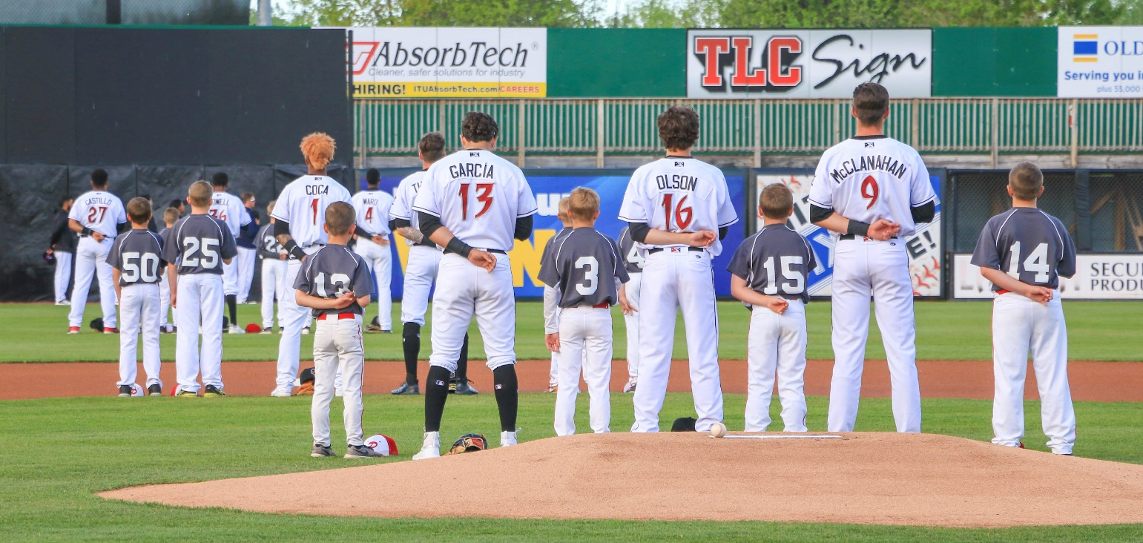

Please make checks out to Ultimate Sports Weekend and mail this form with payment to:

Ultimate Sports Weekend
915 Taft Street
Kaukauna, Wisconsin, 54130

* I will call you when I receive this form and talk about the details of your order

